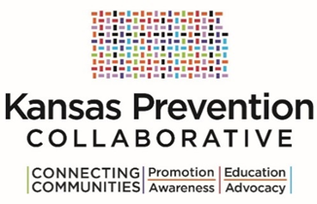
Letter of Intent to Apply
KPCCI FY17 Community Prevention Funds

Instructions

Each coalition interested in applying for the KPCCI FY17 Community Prevention Funds must submit their letter of intent no later than 5:00 p.m. on June 16, 2016.

You may email it to prevprogramreports@kdads.ks.gov.

Request for Proposal Timeline  Release of Request for Proposal | June 9, 2016
Letter of Intent Due | June 16, 2016
Written Questions from Potential Bidders due by 5:00 p.m. | June 20, 2016
Q&A Emailed & Posted by KDADS | June 24, 2016
Applications Due | July 15, 2016 by 5:00 P.M. CST
Notification of Award(s) | August 15, 2016
Grant Start-Up | September 1, 2016

Please review the RFA in its entirety before submitting your letter of intent. Only coalitions that submit this letter will be considered.

Thank you.

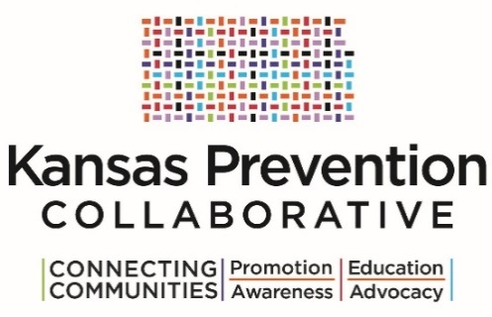
Letter of Intent to Apply
KPCCI FY17 Community Prevention Funds

Coalition Information

Coalition Name | Click here to enter text.
County | Click here to enter text.
Primary Contact Person | Click here to enter text.
Address | Click here to enter text.
Phone Number | Click here to enter text.
E-mail Address | Click here to enter text.

Fiscal Information

Fiscal Agent | Click here to enter text.
Primary Contact Person | Click here to enter text.
Address | Click here to enter text.
Phone Number | Click here to enter text.
E-mail Address | Click here to enter text.

Provide a brief overview (500 words or less) of your coalition and population to be served.
NOTE: Include population to be served (e.g., potential geographic area; demographics).

Click here to enter text.

