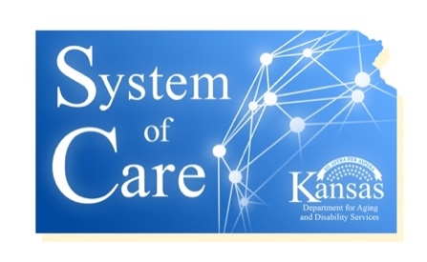
Agenda
Cultural Awareness Committee
October 9, 2019
4:00 PM – 5:00 PM
877-400-9499 // 867-102-1548

Attendees: Isiah Lykes, Mike McAllister, Kim Fisher, Linda Buchheister, Jane Adams, Debra Garcia

- Marketing Slick Edit Review
The cultural competency practice tips marketing slick underwent review at the last committee meeting in order to reduce the number of words for a more readable resource tool. The edits will be reviewed and further recommendations for improvement accepted.
- New committee members joining the call necessitated a recap to date of the committee’s work and progress on CLC tasks. Committee members were brought up to speed on where the team is at in the process of developing a cultural competency plan for the grantee partners. The basic CLC plan is completed and the marketing slick edits recommended from last CLC meeting were reviewed by the committee. Kim Fisher suggested we add some links on the slick to reference KDADS, Facebook access to SOC, and the source document from HNS as the source of our cultural competency tips. These links will be added, reviewed again by the committee, and then the document should be ready to go to print. Jane suggested we have some experts review the cultural competency plan documents and marketing materials. She will provide Debra with contact information on who is qualified as an expert on cultural competency and would be willing to review. There was some discussion on what other CLC activities the committee should undertake and the importance of growing our participation in the committee to include a more diverse representation and perspective. At the very least, we would like to have an advisory board of members outside of the CMHC’s to help us assess the competency of our cultural competence efforts. Jane has an example of an accordion style tool that provides a way to do a drill down on tips. Jane will get the example to Linda who will take to Debra. Although some felt less is more, it may be useful to present the information in a variety of resource styles to promote maximum utilization of the tools by staff’s preferences. The use of Relias online trainings for Cultural Competency at the CMHC’s was discussed. Mike invited Debra to attend an active online training in order to preview / review the content. Kim expressed a need for more information on the trainings in order to approach her management team about using Relias as the source for CLC trainings. Debra and Mike will take the tests and notes on 10/11 and provide the team with specifics on the Relias program next CLC committee.

Next CLC Committee: November 6th

