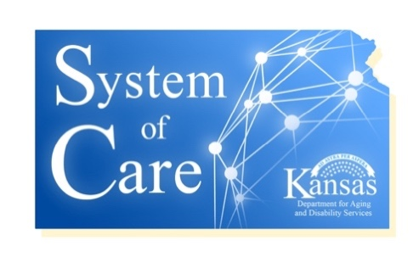
Discovery for Success
Committee NOTES
October 10, 2019, 4:30pm

- Attending: Debra Garcia, Nicole Freund, Janell Stang, Linda Buchheister, Grace Lamberton, Barbara Huff, Mike McAllister, Angela Heller-Workman, Susan Montague
- ThoughtExchange
  - https://my.thoughtexchange.com/#362667756
  - Continue adding and rating thoughts over the next couple of days and Nicole will send a report after.
  - We will continue discussing how this can be used within SOC at the next meeting.
  - What questions could we ask?

Next meeting is scheduled for: November 7th @ 4:30

